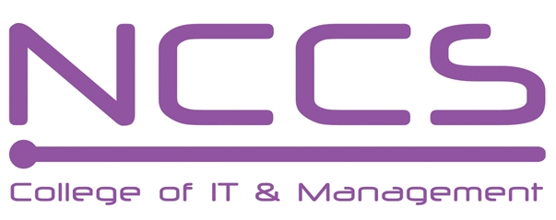
National College of Computer Studies
(NCCS-College of IT & Management)
Final Examination (2023)
B.Sc. CSIT /First Semester/ CSC-114: Introduction to Information TechnologyCandidates are required to answer the questions in their own words as far as practicable.

Full Marks: 60
Pass Marks: 30
Time: 3 Hours

Set A

Group ‘A’

Attempt Any Two Questions: [2×10=20]
- Define Operating system. Explain the activities handled by each of the following functions of the OS (i) Process Management, (ii) Memory Management, (iii) File Management, (iv) Device Management, (v) Protection and Security, and (vi) User Interface [1+9]
[[
- “Networking allows sharing of information and resources”. Justify it. Explain the types of network topologies with their advantages and disadvantages. [2+8]
- Differentiate between data warehousing and data mining. Explain any four types of databases. [2+8]

Group ‘B’
Attempt Any Eight Questions: [8×5=40]
- Highlight the differences between microcomputer, minicomputer, mainframe computer and supercomputer.
- Explain the main components in a computer case.
- Explain briefly about primary memory and secondary memory.
- Explain about OCR, OMR and MICR.
- Convert 1011.1001 from Base 2 to Base 10. Then convert the result from base 10 to base 2.
- Define Multimedia. Explain its impact on (i) Education (ii) Entertainment (iii) Business, and (iv)
Training. [1+4]
- Define Computer Security. Explain Secret Key Cryptography and Public-Key Cryptography. [1+4]
- Describe briefly the LAN, MAN, and WAN transmission technologies.
- Write short notes on any two: [2.5 +2.5]
- TCP/IP
- Cloud Computing
- e-governance

********
National College of Computer Studies
(NCCS-College of IT & Management)
Final Examination (2023)
B.Sc. CSIT /First Semester/ CSC-114: Introduction to Information TechnologyCandidates are required to answer the questions in their own words as far as practicable.

Full Marks: 60
Pass Marks: 30
Time: 3 Hours

Set B

Group ‘A’

Attempt Any Two Questions: [2×10=20]
- Define System software. Explain each of the following types of OS with examples (i) Single user and Single Task, (ii) Single user and Multitasking, (iii) Multiuser, (iv) Multiprocessing, and (v) Real time [1+9]
- List the seven layers of the OSI model protocol, in order. How does the OSI seven-layer protocol work? Describe briefly the function of each layer of the OSI model. [1+ 2+ 7]
- Difference between Database and Datawarehouse. Explain in details about the types Database architecture in DBMS. [2+ 8]
Group ‘B’
Attempt Any Eight Questions: [8×5=40]
- Define (i) Program (i) Software (iii) Hardware (iv) ALU (v) CU (vi) CPU (vii) Data.
- Highlight the difference between Data bus, address bus and control bus.
- Describe briefly about the Sequential access devices and Direct access devices
- Explain the working of the I/O system
- Convert 4D.21 from Base 16 to Base 10. Then convert the result from base 10 to base 16.
- Describe the characteristics of multimedia system.
- Explain three technologies used for implementing the security mechanisms.
- Differentiate between packet switching and circuit switching techniques.
- Write short notes on any two: [2.5 + 2.5]
  - FTP
  - Search Engine
  - e-commerce

********

